Economic botany

Abulais Shomrat
AE-74, Batch: 2016-17 (64th)
Department of Botany
University of Dhaka

Foods from plants

Cereals
- A cereal is any edible components of the grain (botanically, a type of fruit called a caryopsis) of cultivated grass, composed of the endosperm, germ, and bran. Cereal grains are grown in greater quantities and provide more food energy worldwide than any other type of crop and are therefore staple crops. Edible grains from other plant families, such as buckwheat (Polygonaceae), quinoa (Amaranthaceae) and chia (Lamiaceae), are referred to as pseudocereals.

Scientific name | Family | Bangla name | Common name | Photo
Oryza sativa | Poaceae | ধান  Dhan | Rice | 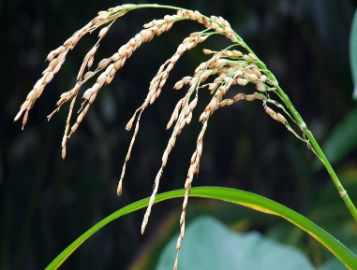
Zea mays | Poaceae | ভুট্টা  Bhutta | Corn | 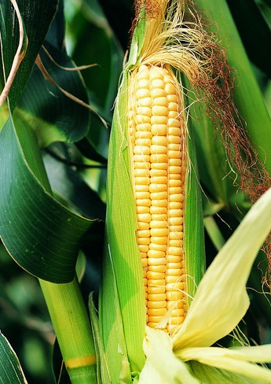
Hordeum vulgare | Poaceae | বার্লি  Barley | Barley | 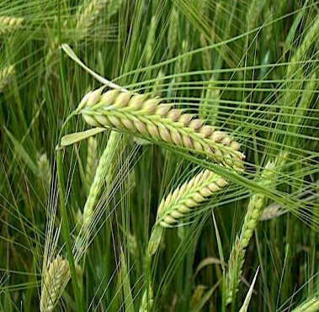
Triticum aestivum | Poaceae | গম  Gom | Wheat | 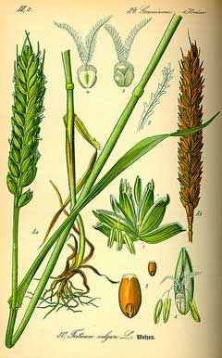

Millets
- Amount of carbohydrate is less.
- Millets are a group of highly variable small seeded grasses, widely grown around the world for fodder and human food. Generally, the millets are small-grained, annual, warm weather cereals belonging to grass family. They are highly tolerant of drought and other extreme weather conditions.

Setaria italica | Poaceae | কাউন  Kaun | Foxtail millet | 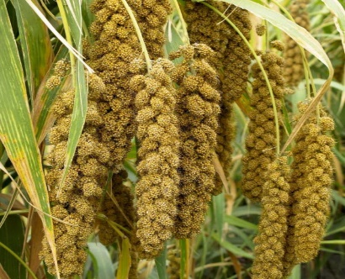
Fagopyrum esculentum | Polygonaceae | বাজরা  Bajra | Buck wheat | 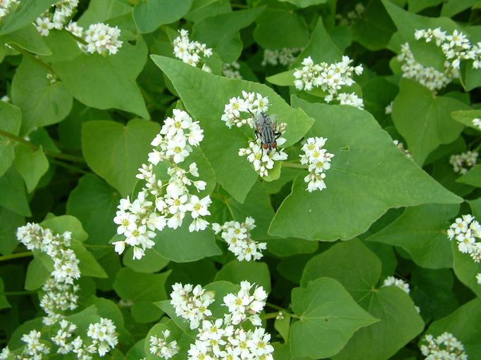

Legumes

Nuts

Pulse

Fruits
i. Temperate

Malus domestica |  | আপেল  Apple | Apples | 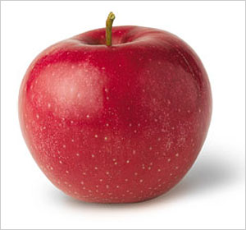
Pyrus communis |  | Nashpati | Pear | 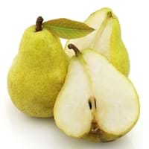
Fragaria * ananassa |  | স্ট্রবেরী  Strawberry | Strawberry | 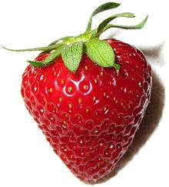

ii. Tropical

Mangifera indica |  | আম  Aam | Mango | 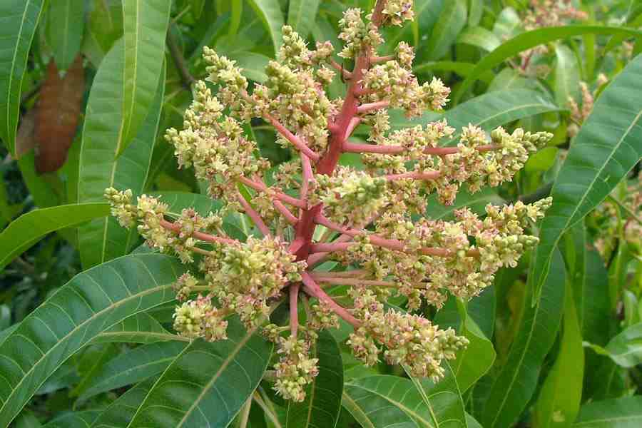
Psidium guajava |  | পেয়ারা  Peyara | Guava | 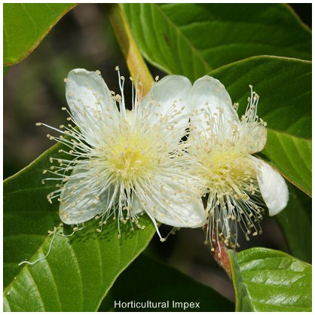

Plant fibre includes:
- Malvaceae
- Liliaceae

Rubber, resin, gum, tea, coffee

Important plants and plant products
(5 categories)

1. Foods:
- Cereals and millets
- Legumes and nuts
- Vegetables
- Fruits – a. Temperate, b. Tropical

2. Plants and plant products of industrial use:
- Rubber
- Fibre and fyf
- Cellulose
- Tannin and dye
- Wood and cork
- Gums and resin
- Pectine

3. Medicinal plants and drugs
- Medicinal plants
- Fumatories (smoke) and masticatories
- Alcaloids
- Glucoside

4. Food adjuncts
- Spices and condiment (preparations used to enhance flavour and taste of food).
- Vitamin
- Non-alcoholic beverage
- Alcoholic beverage

6. Lower plants of economic use
- Fungi
- Lichen
- Algae

Good to know
- 95-98% rubber comes from Euphorbiaceae family.
- Fibres can be categorised into 6 main groups
i. Brush
ii. Textile
iii. Filling
iv. Rough weaving
v. Natural fabrics
vi. Paper making fibre
- Dye: Indigophera indica
- Pectine is fruit jelly.

3 other uses of plants:
- The role of colorless plants in the economy of nature.
- Bacteria play in different diseases.
- Effect of forest plants and natural vegetation in controlling flood and soil erosion.
Vetiveria zizanioides (Vetiver grass) - Poaceae.

Lichen: In case of scarcity of food.
Drugs (Algotin): Claviceps purpurea (ergot fungi)
Gum of Arabic: Acacia Senegal - Fabaceae

Medicinal plants

A plant which possess medicinal properties is known medicinal plant.

Medicinal plant is a plant that synthesizes and accumulates secondary metabolites and possess thermapeutic properties or exerts pharmacological effect on animal body particularly on human body.

According to WHO consultative group of medicinal plants,
A medicinal plant is any plant in which one or more organs contain substances that can be used for therapeutic purposes or which is a precursor for synthesis of useful drug.

Good to know:
- 21,000 medicinal plants as listed by WHO.
- BARC stands for Bangladesh Agricultural Research Council.
- M. Salar Khan is the father of angiosperm taxonomy of Bangladesh.
He conducted Botanical Survey of East Pakistan in 1971.
- There are about 1,000 medicinal plants in our country.

Book | Writer | Year | Number of MP | Remarks
Medicinal Plants of Bangladesh: A Preliminary List Giving Actions and Uses | M. Salar Khan and  Ahmed Mozaharul Huq (A M Huq) | 1975 | 182 species | Published by BARC
Our Medicinal Plant Wealth | Md. Abul Hassan and  A M Huq | 1993 | 499 species
Medicinal Plant of Bangladesh | Prof. Abdul Goni | 2003 | 455 species | Chemical constituents and uses
Medicinal Plant of Bangladesh | Dr. Md. Yusuf | 2007 | 747 species | 1994- First edition  2007- Second edition
 |  | 2010 |  | The Ministry of Agriculture
 |  | 2005 |  | Medicinal Plant Protection Act

Classification of medicinal plants
Abrus precatorius: Kuch – Climber - Red seed - Used in 17 diseases

According to habitat

Type | Scientific name | Family | Bangla name | Common name
 | Acalypha indica | Euphorbiaceae |  | Indian mercury, Indian copperleaf | 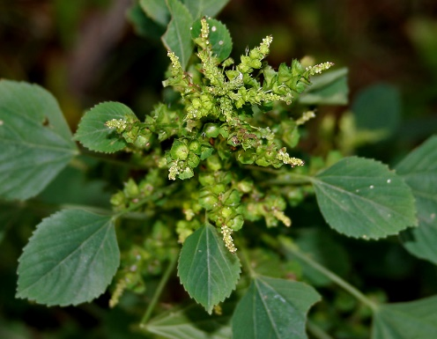
 | Andrographis paniculata | Acanthaceae
 | Boerhavia diffusa
 | Centella asiatica
 | Cynodon dactylon
Herb | Chenopodium album
 | Chenopodium ambrosioides
 | Eclipta alba
 | Euphorbia hirta
 | Aristolochia indica
 | Bacopa monnieri
 | Asparagus racemosus
 | Gloriosa superba
 | Leucas aspera
 | Mentha arvensis
 | Scoparia dulcis
 | Achyranthes aspera
 | Ageratum conyzoides

 | Abroma augusta
 | Adhatoda zeylanica
 | Calotropis procera
 | Calotropis gigantean
 | Datura metel
 | Glycosmis pentaphylla
 | Ricinus communis
 | Lawsonia inermis
 | Ocimum tenuiflorum
Shrub | Ocimum graticimum
 | Cassia sl.
 | Cassia S. stri.
 | Senna
 | Chaemicrista
 | Cassia nodusa
Cassia alata
to Senna alata
 | Cleodendrum viscosum
 | Cleodendrum indicum

 | Acacia nilotica
 | Acacia catechu
 | Aegle marmelos
 | Aphanamyxis polystachya
 | Azadirachta indica
 | Carica papaya
 | Cinnamomum tamala
 | Cinnamomum verum
 | Terminalia arjuna
Tree | Terminalia chebula
 | Terminalia belliria
 | Oroxylum indicum
 | Alstonia scholaris
 | Punica granatum
 | Saraca asoca

According to habit

Tree | Holarrhena antidysenterica (bud) | Apocynaceae | Hoimonti, Kurchi
 | Litsea glutinosa (leaf) | Lauraceae | Menda | Bolly gum

 | Allamanda cathartica | Apocynaceae |  |  | Golden trumpet |  | 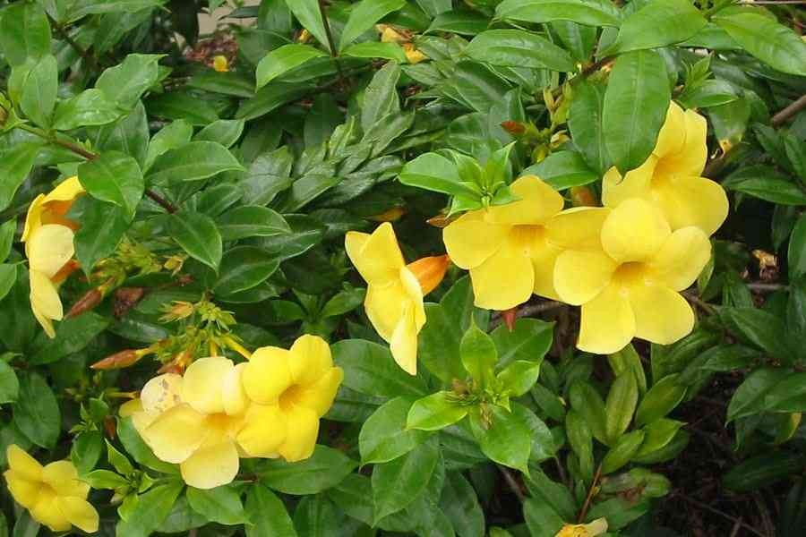
 | Asparagus racemosus | Liliaceae | Shotomulii |  |  |  | 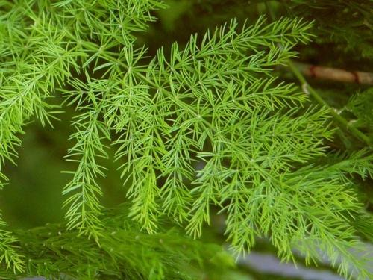
 | Aristolochia indica | Aristolochiaceae | Ishwar mul
Climbers | Tinospora cordiflora |  | Doloncho |  |  |  | 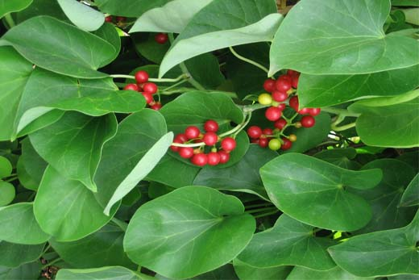
 | Hemidesmus indicus |  | Onontomuul |  |  |  | 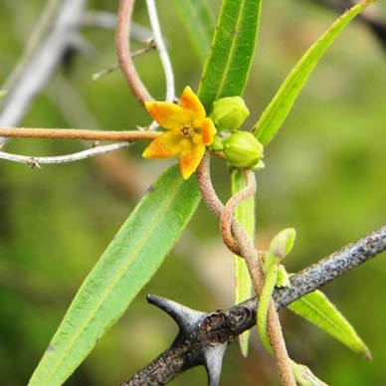
 | Coccinia grandis | Cucurbitaceae | Telakucha |  | Ivy gourd |  | 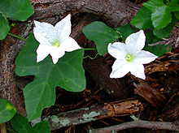
 | Momordica charantia |  | Kakrol
 | Abrus precatorius |  | Kuch
 | Cuscuta reflexa | Cuscutaceae | Swarno lota |  |  |  | 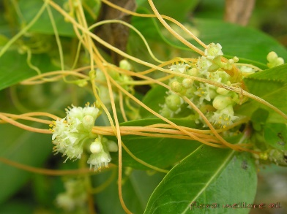
Parasite | Cassytha filiformis |  | Akash bel |  |  |  | 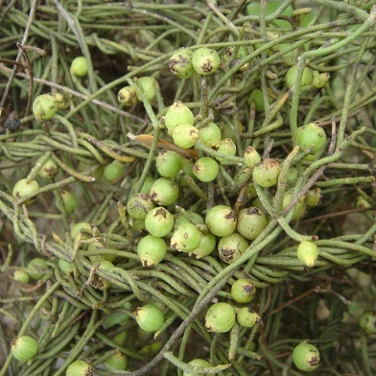
 | Dendrophthoe falcata |  | Boro menda |  |  |  | 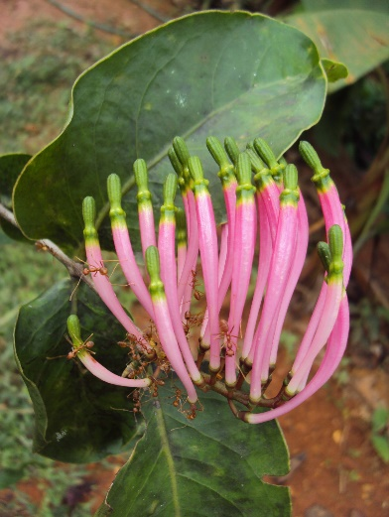
Epiphyte | Vanda tessellata | Orchidaceae |  | Rasna |  |  |  | 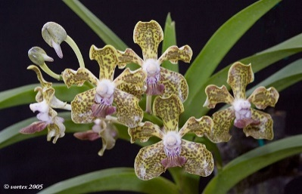

According to parts used

 | Andrographis paniculata | Acanthaceae | কালোমেঘ  Kalo megh | Crete | 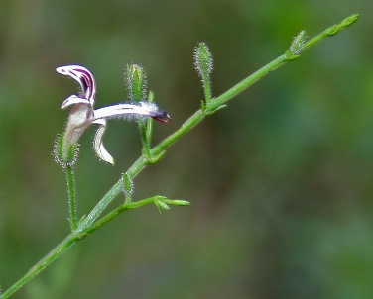
 | Cynodon dactylon | Poaceae | দুর্বাঘাস  Durba ghas |  | 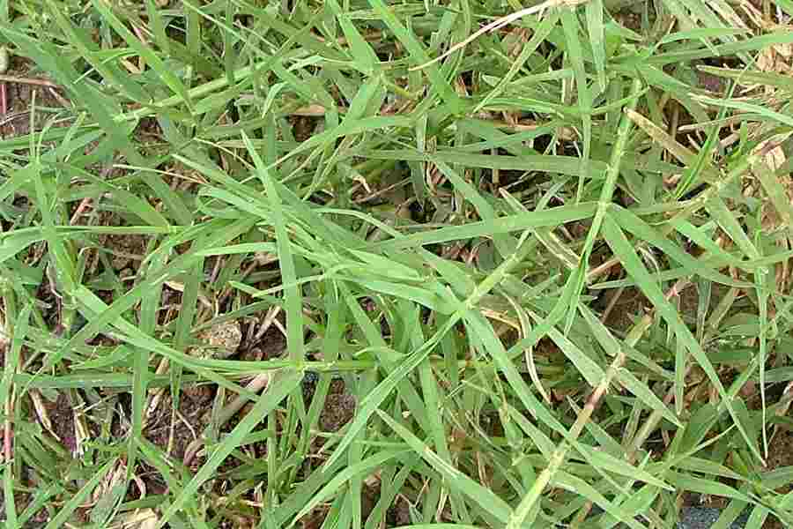
Whole plant | Boerhavia diffusa | Nyctaginaceae | পুনর্ভবা  Punorvoba |  | 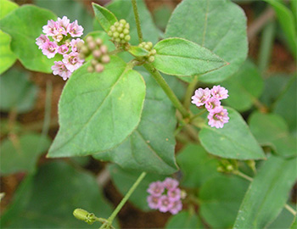
 | Phyllanthus niruri | Phyllanthaceae | ভুঁই আমলা  Bhui amla | Gale of the wind, stone breaker, seed under leaf | 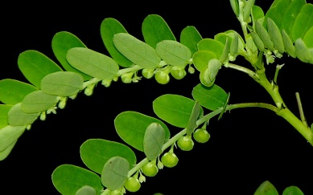
 | Cuscuta reflexa | Cuscutaceae | স্বর্ণলতা  Swarno lota |  | 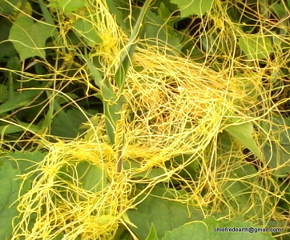
 | Scroparia dalsis
 | Acacia catechu | Minosaceae | খয়ের  Khoyer |  | 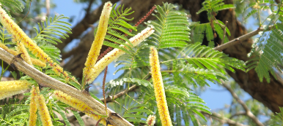
Stem | Alstonia scholaris | Apocynaceae | ছাতিম  Chatim |  | 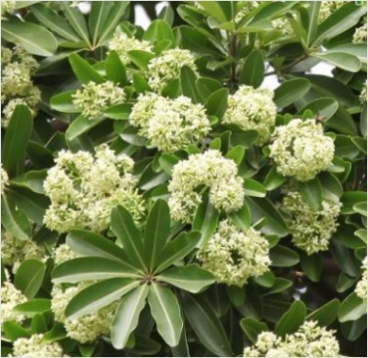
 | Aphanamixis polystachya | Meliaceae | পীতরাজ  Pit raaj |  | 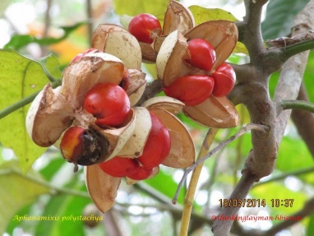
 | Acorus calamus | Acoraceae | বচ  Boch | Sweet flag | 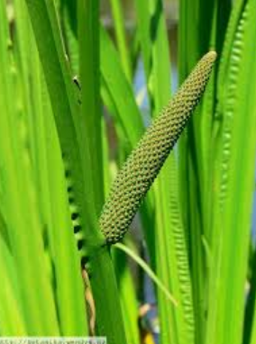
 | Aristolochia indica | Aristolochiaceae | ঈশ্বরমূল  Ishwar mul |  | 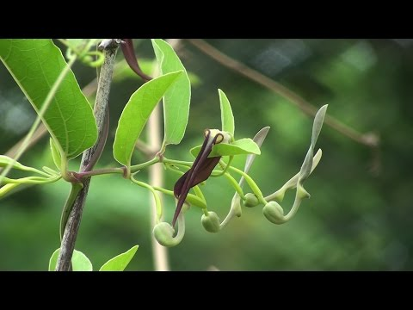
 | Asparagus racemosus | Liliaceae | শতমূলী  Shoto muli |  | 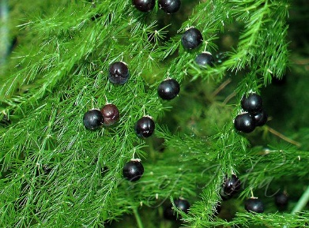
 | Hemidesmus indicus | Asclepiadaceae | অনন্তমূল  Ononto mul |  | 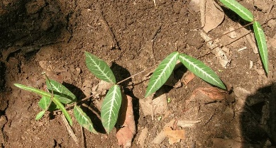
 | Withania somnifera | Solanaceae | অশ্বগন্ধা  Oswa gandha |  | 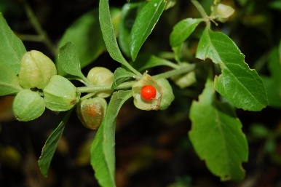
Root | Rauvolfia serpentina | Apocynaceae | স্বর্পগন্ধা  Sorpo gondha | Snake root, Devil pepper | 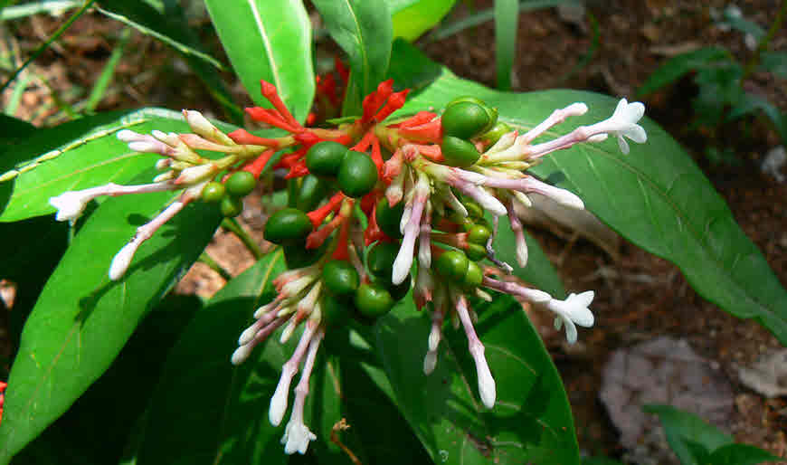
 | Catharanthus roseus | Apocyncaceae | নয়নতারা Noyon tara | Periwinkle | 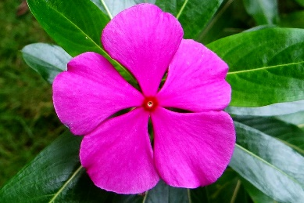
 | Azadirachta indica (Leaf and bark) | Meliaceae | নিম  Neem | Neem | 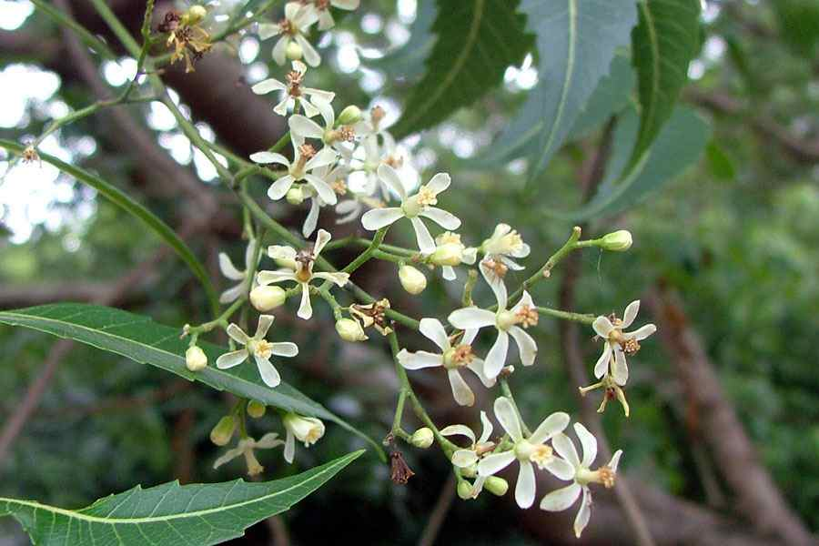
 | Cinnamomum verum | Lauraceae | দারুচিনি  Daruchini |  | 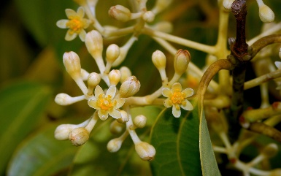
More than one parts | Curcuma zedoaria | Zingiberaceae | বন আদা  Bon ada | White tumeric | 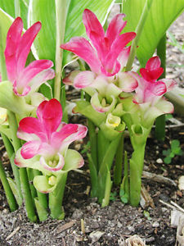
 | Litsea glutinosa | Lauraceae | মেন্দা  Menda | Bollygum | 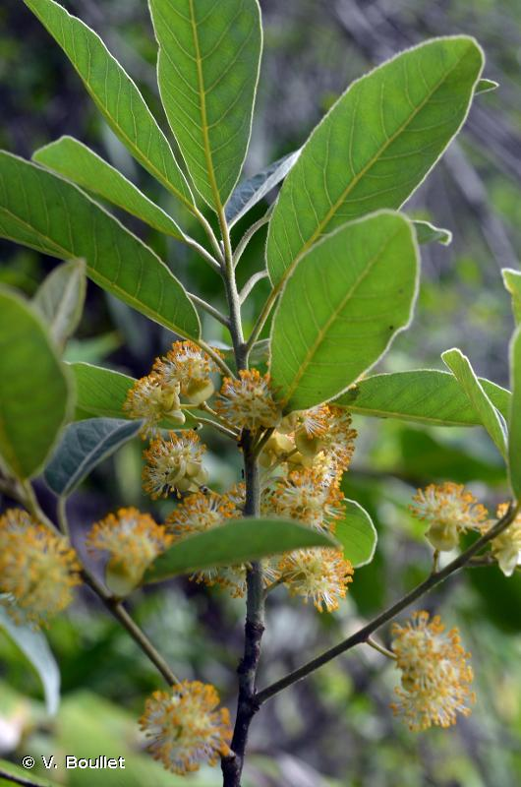
 | Senna alata | Caesalpiniaceae | দাঁতমর্দন  Datmordon | Emperor’s candlestick | 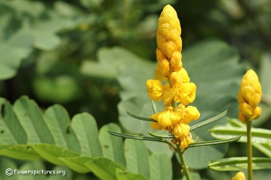
 | Aloe indica | Liliaceae | ঘৃতকুমারী  Ghrito kumari | Indian aloe | 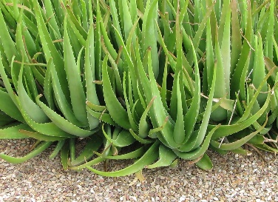
Leaf | Lawsonia inermis | Lythraceae | মেহেদী  Mehedi | Henna | 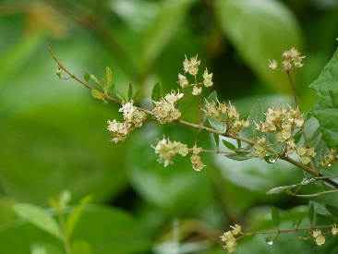
 | Clerodendrum viscosum | Lamiaceae | ভাট  Bhat |  | 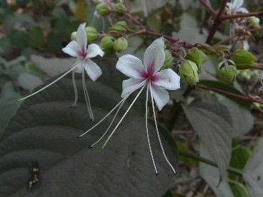
 | Piper betle | Piperaceae | পান  Paan | Betel leaf | 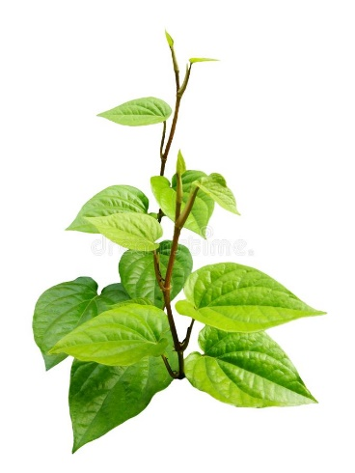
 | Bryophyllum pinnatum | Crassulaceae | পাথরকুচি  Patharkuchi | Life plant | 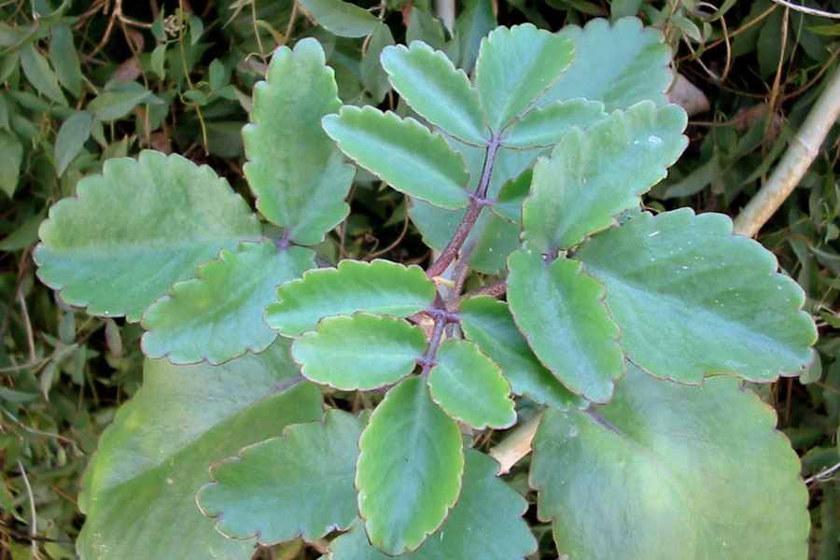
 | Adhatoda vasica | Acanthaceae | বাসক  Basok | Malabar nut | 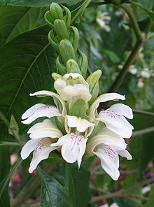
 | Calendula officinalis | Asteraceae | ক্যালেন্ডুলা  Calendula | Marigold | 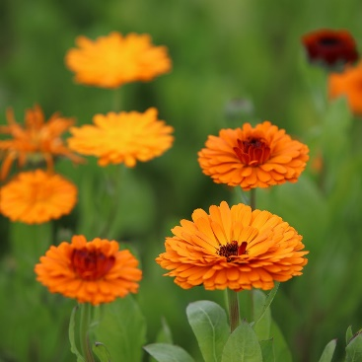
 | Hibiscus rosa-sinensis | Malvaceaea | জবা  Joba | China rose | 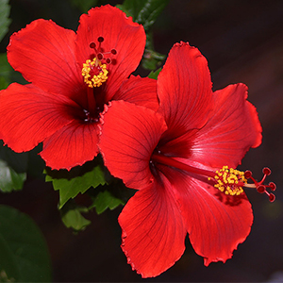
 | Tagetes erecta | Asteraceae | গাঁদা  Gnada | Aztec Marigold | 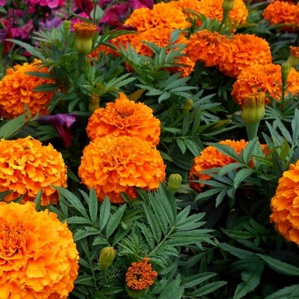
Flower | Carthamus tinctorius | Asteraceae | কুসুম  Kusum | Safflower
 | Rosa centifolia
 | Aegle marmelos | Rutaceae | Bel | Golden apple, stone apple, wood apple | 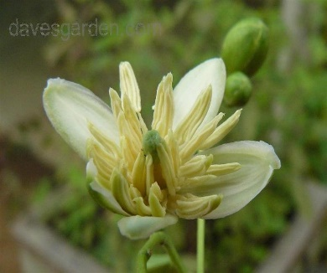
Fruit | Ananas sativus | Bromeliaceae | Ananros | Pine apple | 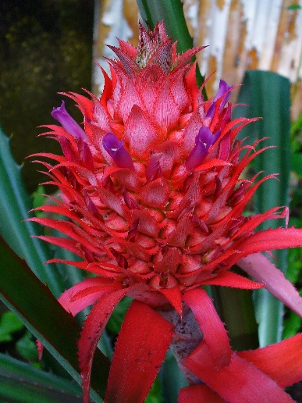
 | Averrhoa carambola | Oxalidaceae | Amra | Carambola, star fruit | 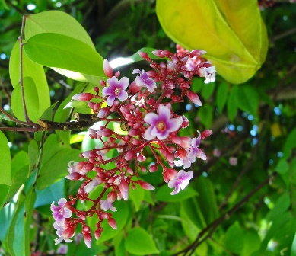
 | Punica granatum | Lythraceae | Dalim | Pomegranate | 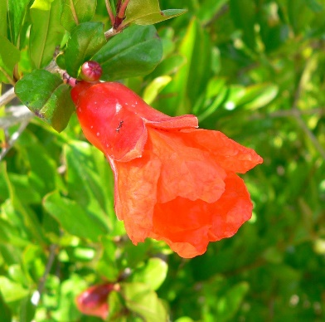
 | Momordica dioica | Cucurbitaceae | Korola | Spiny gourd
 | Vitex negundo |  | Nishinda | Chinese chaste tree
 | Abrus precatorius | Fabaceae | Kuch | Coral bead, crab’s eye, love pea | 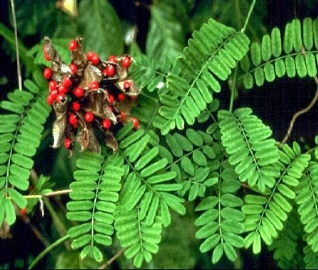
 | Nigella sativa | Ranunculaceae | Kalo jira |  | 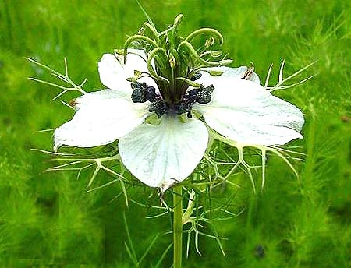
Seeds | Ricinus communis | Euphorbiaceae | Reri | Castor oil plant | 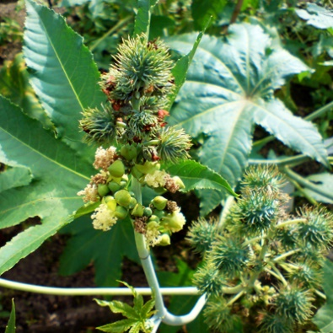
 | Bixa orellana |  | Lotkon | Arnotta plant
 | Croton tiglium |  | Joyfol | Croton oil plant
 | Trigonella foenum-graceum | Fabaceae | Methi |  | 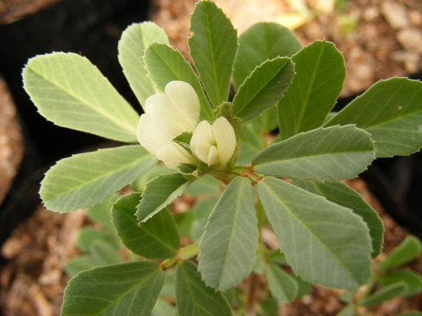

Plants used for disease treatment
 | Terminalia arjuna | Combretaceae | অর্জুন  Arjun |  | 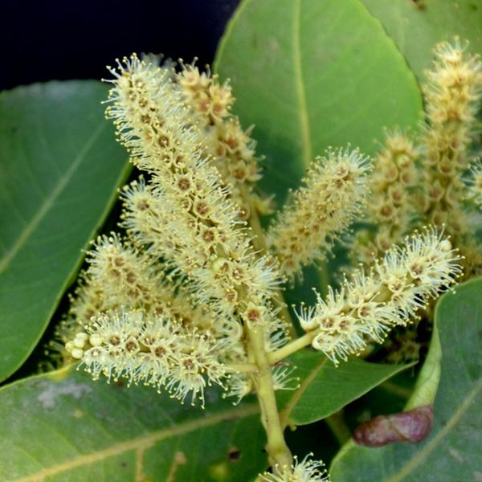
 | Terminalia chebula | Combretaceae | হরিতকি  Haritoki | Chebulic myrobalam | 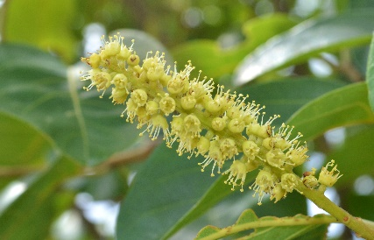
Cardiac disease | Tinospora cordifolia | Menispermaceae | গুলঞ্চ  Guloncho |  | 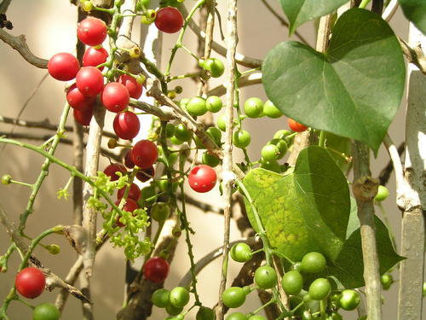
 | Punica granatum | Lythraceae | ডালিম  Dalim |  | 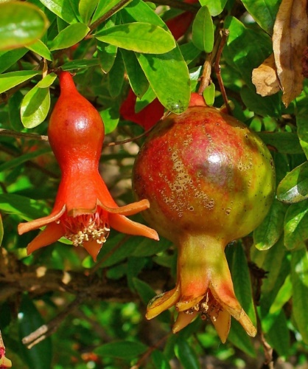
 | Calotropis procera
 | Holarrhena antidysenterica (Bark) | Apocynaceae | হৈমন্তী, কুর্চি  Hoimonti, Kurchi |  | 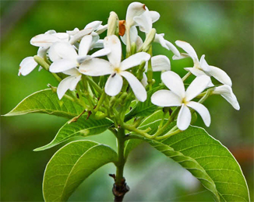
 | Centella asiatica | Apiaceae | থানকুনি  Thankuni | Indian pennywort | 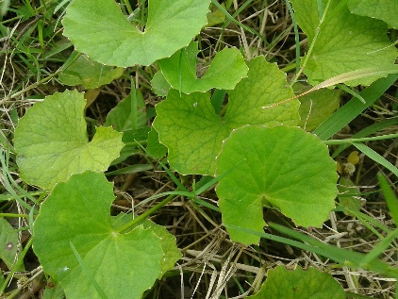
Dysentry | Aegle marmelos | Rutaceae | বেল  Bel |  | 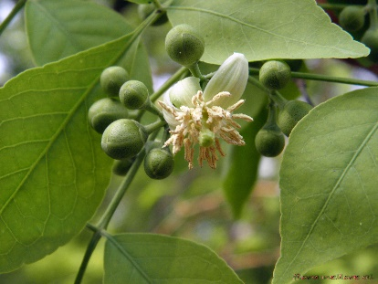
 | Calotropis gigantea | Apocynaceae | আকন্দ  Akondo |  | 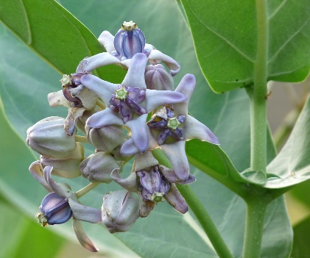
 | Litsea glutinosa | Lauraceae | মেন্দা  Menda
 | Terminalia chebula | Combretaceae | হরিতকি  Haritoki
 | Phyllanthus niruri | Phyllanthaceae | ভুঁইআমলা  Bhui amla |  | 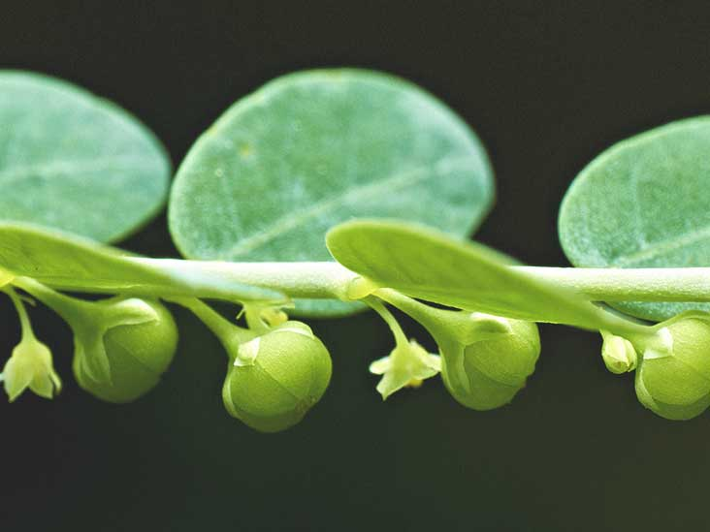
 | Boerhavia diffusa | Nyctaginaceae | পুনর্ভবা  Punorvoba |  | 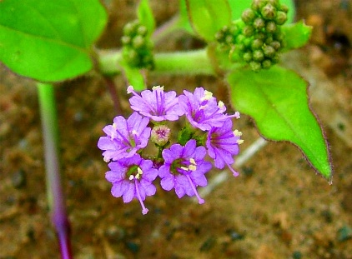
Jaundice | Cajanus cajan | Fabaceae | অড়হড়  Orhorr |  | 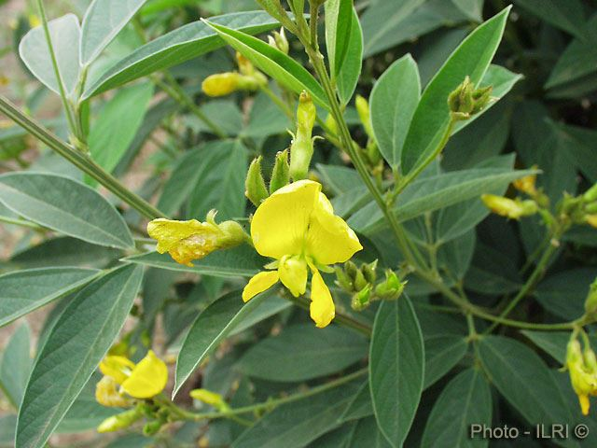
 | Asparagus racemosus | Liliaceaea | শতমূলী  Shotomuli |  | 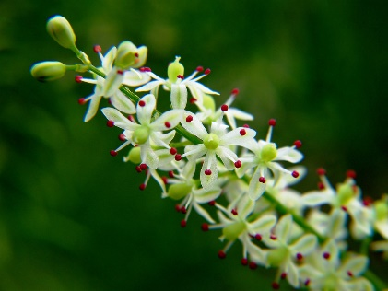
 | Argemone mexicana |  | শিয়ালকাঁটা  Shialkata
 | Eclipta album |  | কালোকেশী  Kalokeshi
 | Coccinia grandis | Cucurbitaceae | তেলাকুচা  Telakucha | Scarlet gourd
 | Cinnamomum tamala | Lauraceae | তেজপাতা  Tej pata | Bay leaf | 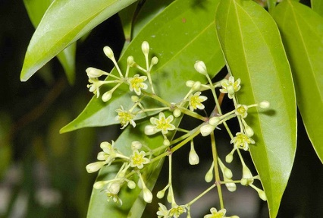
 | Momordica charantia | Cucurbitaceae | করলা  Karla |  | 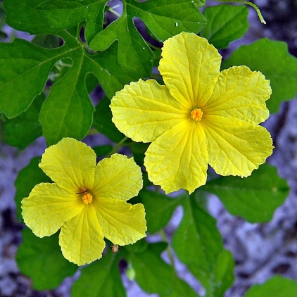
 | Cajanus cajan | Fabaceae | অড়হড়  Orhorr | Pigeon pea
Diabetes | Trigonella foenum-graecum | Fabaceae | মেথী  Methi
 | Syzygium cumini |  | জাম  Jaam
 | Ficus benghalensis |  | বট  Bot
 | Barringtonia acutangula |  | হিজল  Hijal
 | Acacia nilotica | Minosaceae | বাবলা  Babla
 | Acalypha indica | Euphorbiaceae | মুক্তাঝুড়ি  Mukta jhuri | Cat’s tail | 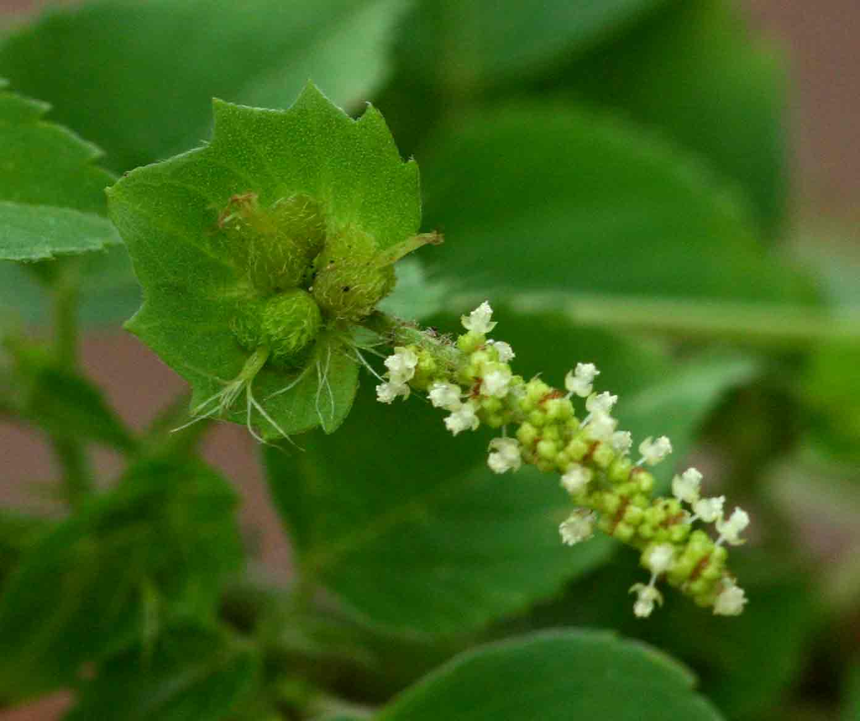
 | Adhatoda vasica | Acanthaceae | বাসক |  | 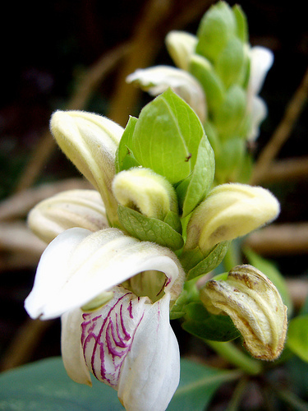
Asthma | Piper nigrum | Piperaceae | গোল মরিচ  Gol morich | Black pepper | 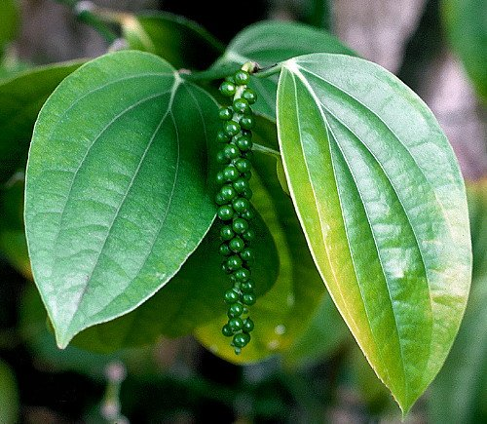
 | Euphorbia hirta | Euphorbiaceae | দুধিয়া  Dudhia |  | 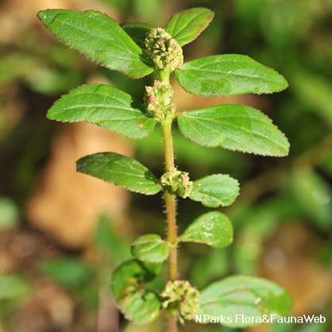
 | Acorus calamus | Acoraceae | বচ  Boch |  | 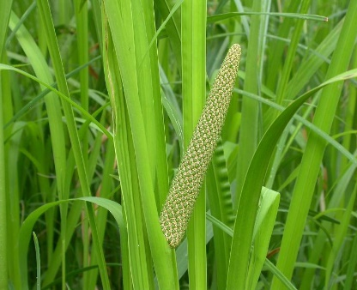
 | Calotropis gigantea | Apocynaceae | বড় আকন্দ  Boro akondo
 | Andrographis paniculata | Acanthaceae | কালোমেঘ  Kalo megh | Crete | 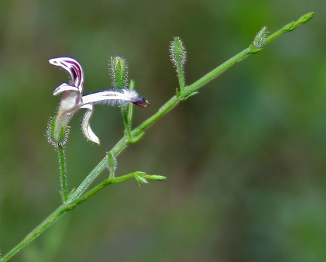
Anthelmintic | Punica granatum | Lythraceae | ডালিম  Dalim
 | Azadirachta indica | Meliaceae | নিম  Neem |  | 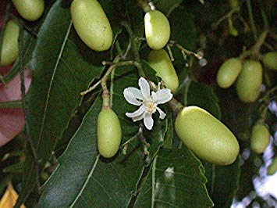
 | Carica papaya | Caricaceae | পেঁপে  Pepe |  | 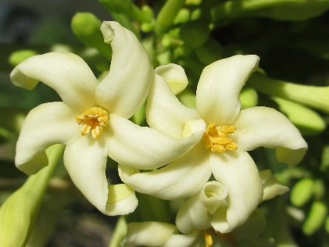
 | Euphorbia hirta | Euphorbiaceae | দুধিয়া  Dudhia
 | Aegle marmelos | Rutaceae | বেল  Bel |  | 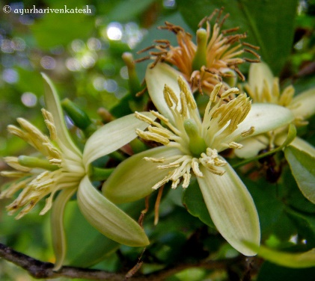
Diarrhoea | Andrographis paniculata | Acanthaceae | কালোমেঘ  Kalo megh | Crete
 | Centella asiatica | Apiaceae | থানকুনি  Thankuni | Indian pennywort

